C# Sharp which is a Menu-Driven Program to perform a simple calculation.-Switch Case

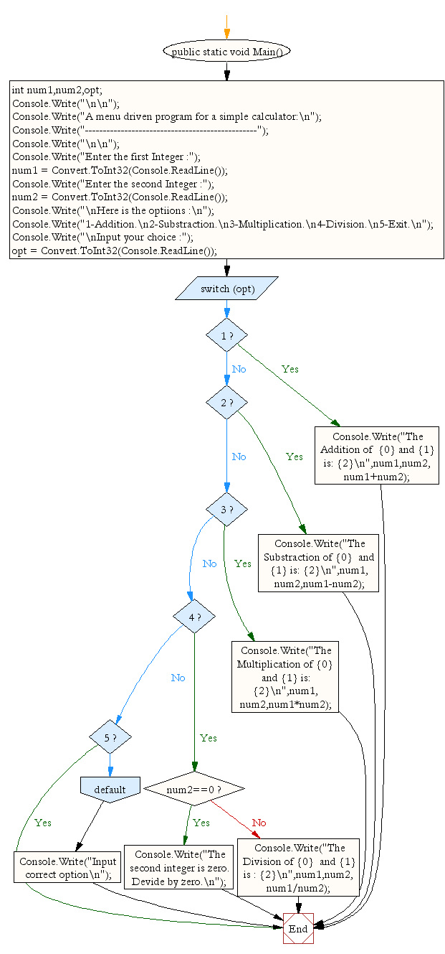

C# Sharp which is a Menu-Driven Program to compute the area of the various geometrical shape.

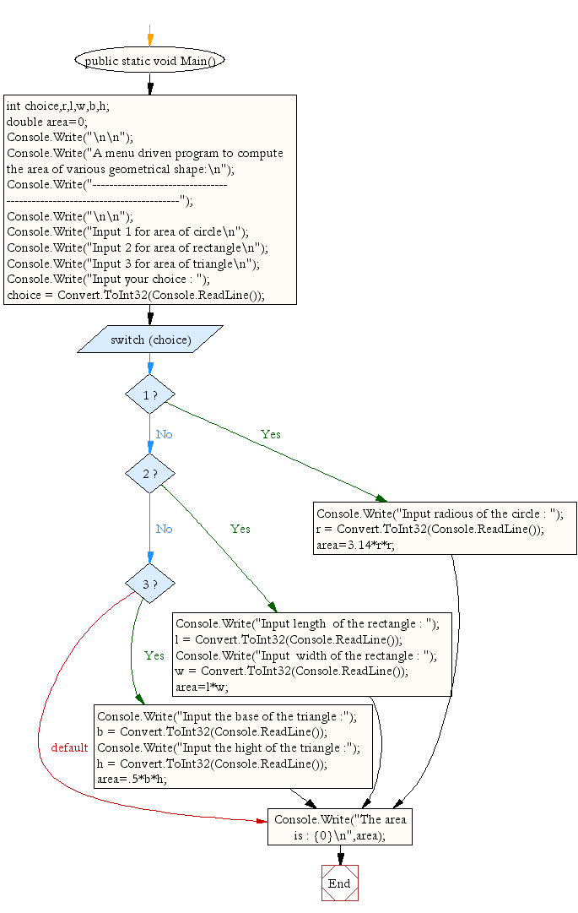

C# Sharp to read any Month Number in integer and display the number of days for this month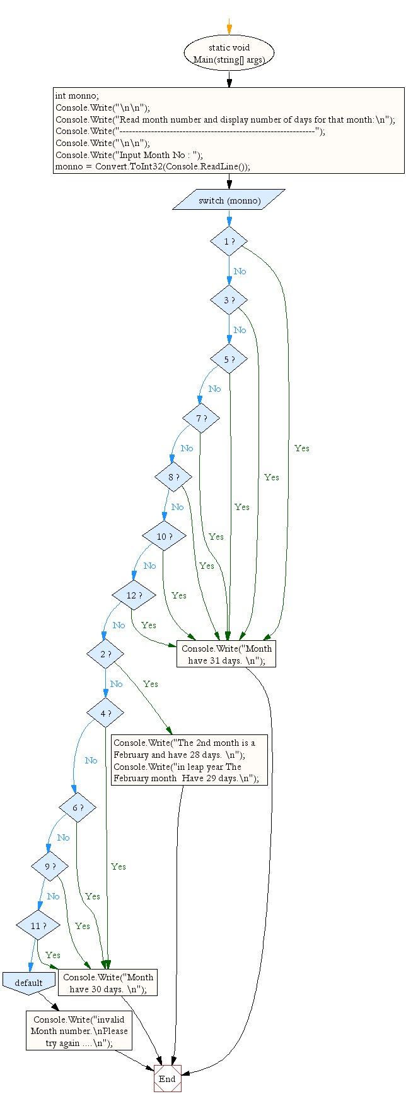

C# Sharp to read any Month Number in integer and display Month name in the word. 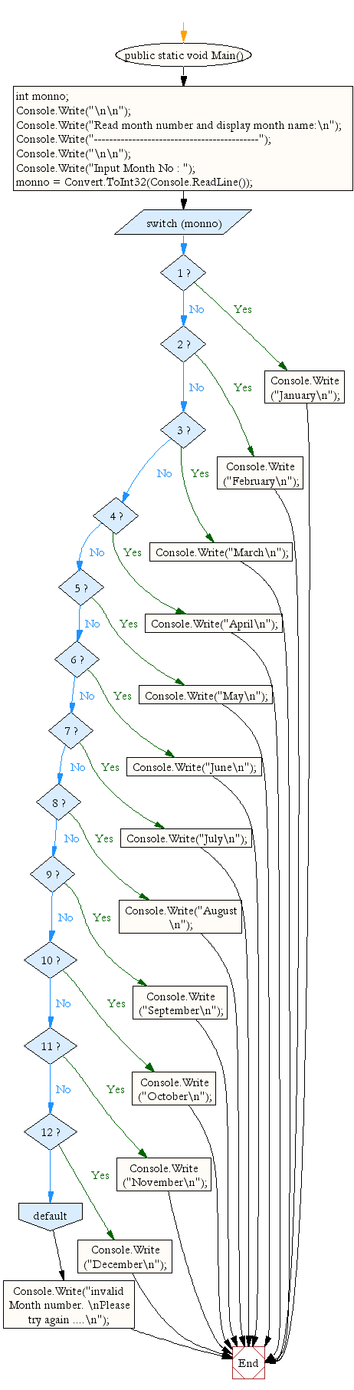

C# Sharp to read any digit, display in the word.

 C# Sharp to read any day number in integer and display day name in the word.

C# Sharp to accept a grade and display the equivalent description:

|  |  |
| --- | --- |
| **Grade** | **Description** |
| E | Excellent |
| V | Very Good |
| G | Good |
| A | Average |
| F | Fail |

C# Sharp to calculate and print the Electricity bill of a given customer. The customer id., name and unit consumed by the user should be taken from the keyboard and display the total amount to pay to the customer. The charge are as follow:

|  |  |
| --- | --- |
| **Unit** | **Charge/unit** |
| upto 199 | @1.20 |
| 200 and above but less than 400 | @1.50 |
| 400 and above but less than 600 | @1.80 |
| 600 and above | @2.00 |

If bill exceeds Rs. 400 then a surcharge of 15% will be charged and the minimum bill should be of Rs. 100/-

C# Sharp program to calculate profit and loss on a transaction.

Test Data :  
500 700  
Expected Output :  
You can book your profit amount : 200